**A Convolutional Neural network Approach to Malaria images to detect chnaces of Malaria disease"**

Mundhir almahrizi 15s13655

*Abstract*— **Malaria is one of the most prevailing disease. The presence of different Plasmodium parasites in the victim's blood cells indicates the presence of malaria, a potentially fatal disease spread by bites from female Anopheles mosquitoes. Malaria may result in death if treatment is delayed. While the traditional microscopy approach counts parasites and red blood cells by taking blood samples from the afflicted person, it is labor-intensive and can occasionally produce unreliable findings. Two deep learning models are applied, one is convolutional neural network developed form scratch by working on its layers. Other is pretrained model VGG16 which has been trained on imagenet dataset weights. With pretrained accuracy is 55% while with scratch accuracy is 59%.**

**Keywords— Disease, CNN, Malaria, Deep learning**

**I. Introduction**

Deep learning is one of the sub field in machine learning which comes under the umbrella of Artificial intelligence. Deep learning algorithms are commonly trained using extensive datasets containing labeled information. Through this training process, the algorithms acquire the ability to correlate specific features within the data with their corresponding labels [1]. For instance, in the context of image recognition, the algorithm might develop associations between distinct features within an image such as the object's shape or color and the accurate labeling of that image. This training methodology enables deep learning models to generalize their understanding, enhancing their proficiency in tasks like recognizing patterns and making accurate predictions across various types of data [2]. There are different applications and various domains which are using deep learning. Mainly, in the field of healthcare it has various application. It has helped scientists and doctors to detect diseases and find their early cure which is difficult through manual procedure. Lung cancer, breast cancer, chest cancer mainly in detection of cancerous cells it has proven its effectiveness. This domain utilized picture of effected and unaffected. Due to the extensive use of deep learning (DL) in fields including illness diagnosis, genome synthesis, medical imaging, and drug development, the field of medical research has undergone tremendous change [3]. A number of reasons, including the kind of data included in the models and the processing methods used, are responsible for the significant rise of deep learning in this field. It is essential to stress that the kind of data whether preexisting or curated that a deep learning model is trained on may have a significant influence on the model's success rate.

.

II. LITERATURE REVIEW

When a person is sufferi9ng form Malaria, it has been observed that Plasmodium parasites are found in blood cells of patients which are the sign of malarial occurrence. It occurs when a female mosquito bite [3]. The research has identified the malarial cells detection from the images dataset of 3000 images. This work presents a unique method for identifying malaria parasites from blood cell pictures using a multiheaded attention-based transformer model. Using the Gradient-Weighted Class Activation Map (Grad-CAM) approach, the efficacy of the suggested model is demonstrated. Grad-CAM produces a heatmap graphic that shows which certain sections of an image are prioritized by the suggested model above other areas. With scores of 96.41 for the original malaria parasite dataset and 99.25%, for the modified dataset, the proposed model exhibits remarkable testing accuracy, precision, recall, F1-score, and AUC score.

As the worst illness on Earth, malaria presents a major challenge to health departments around the globe. Traditionally, blood smears from patients are carefully examined under a microscope by trained professionals in order to diagnose malaria. In addition to being ineffective, this procedure greatly depends on the examiner's experience. While deep learning algorithms have been used in the past to diagnose malaria from blood smears, their effectiveness in real-world applications has been limited [4]. In order to detect and forecast infectious cells in thin blood smears on conventional microscope slides automatically, this research presents a unique and incredibly robust machine learning approach based on a Convolutional Neural Network (CNN). By using 27,558 single-cell pictures with a ten-fold cross-validation layer, the research has increase the model performance CNN. Based on accuracy, three types of CNN models are compared: Basic CNN, VGG-19 Frozen CNN, and VGG-19 Fine-Tuned CNN. After the models training and testing one suitable model is selected.

By addressing the shortcomings of the conventional diagnostic technique, this method aims to provide a more automated and effective means of detecting malaria.

These two papers one has used VGG19 and other customized CNN model, but my research will be using sequential model which is created and pretrained model is VGG16.

III. PROBLEM STATEMENT

Due to the loss of red blood cells, malaria can cause anemia and jaundice, which are characterized by yellow coloring of the skin and eyes [5]. If treatment is delayed, the infection may worsen and cause serious side effects such renal failure, convulsions, mental disorientation, coma, and finally death. Because of the Plasmodium falciparum virus, which causes malaria, the disease first appeared in Africa. Because mosquitoes are its carriers, it has spread throughout the world. The virus can survive in warm to moderate temperatures, but not in extremely cold ones. Malaria has a 40-million-year history and may infect many different animals, including humans, from infancy to maturity. The disease can cause symptoms ranging from fever to coma and even death. The illness breaks down white blood cells and interferes with the normal function of organs by directly attacking human blood cells[6]. Malaria may be identified by drawing blood samples from patients and analyzing them under a microscope. A person who has malaria will be alerted to the illness by warning signs that their body will produce. White blood cell activation is started by the body in order to generate an immunological response against malarial cells. Symptoms including a high temperature, headache, nausea, vomiting, stomach discomfort, and in extreme situations, coma, may arise from this.

IV. DATASET

Malarial dataset is used. This dataset is used for the purpose of detecting malaria. It is likely that the training dataset is arranged into subdirectories, with each subfolder representing a class[7].

For binary classification, there might be two subdirectories, one for each class, for malaria-positive or malaria-negative results. Images of blood smear slides that are both infected and uninfected, labeled appropriately, in the corresponding folders. The testing dataset is arranged into subdirectories, each of which represents a class, just as the training dataset. There are images available for evaluating the model's performance. The dataset contains images of infected and uninfected cells of malarial parasite. Source of dataset is Kaggle. Data set is of based on 500 pictured in each test and train folder. Preprocessing is performed by equalizing the size of the dataset. Pictures in the testing and training datasets are 128 by 128 pixels in size, photos are in RGB format. To improve the robustness of the model, data augmentation methods including shearing, zooming, and horizontal flipping are used to the training dataset.

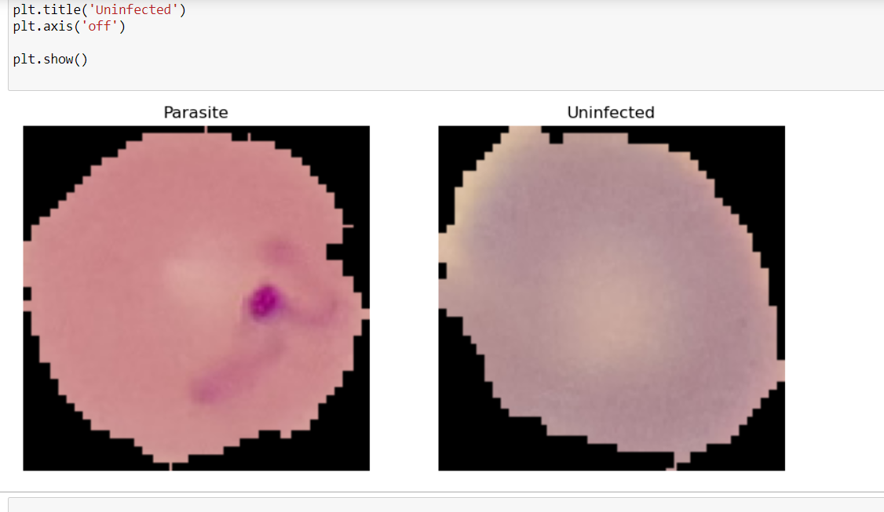

.

IV. METHODs

There are two approaches used to solve the problem. One is building the model from scratch., and other is using VGG16 model which is pretrained on ImagNet weights.

Proposed convolutional neural network model:

Using Keras and TensorFlow, model of convolutional neural networks (CNNs) are used for binary image categorization. In order to make the model form scratch, Three convolutional layers, and each one is followed by max-pooling to do spatial downsampling. Rectified Linear Units (ReLU) are used to activate the filters in the convolutional layers. Two dense layers ensue after the feature maps are flattened, and the last layer uses a sigmoid activation for binary classification [8]. Through convolutional processes, the CNN's architecture seeks to extract hierarchical information from input pictures, while max-pooling minimizes spatial dimensions. Non-linearity is introduced by the ReLU activation, and a probability for binary classification is generated by the final sigmoid activation. For applications like image identification, where hierarchical features are critical for forming decisions, this design is ideally suited

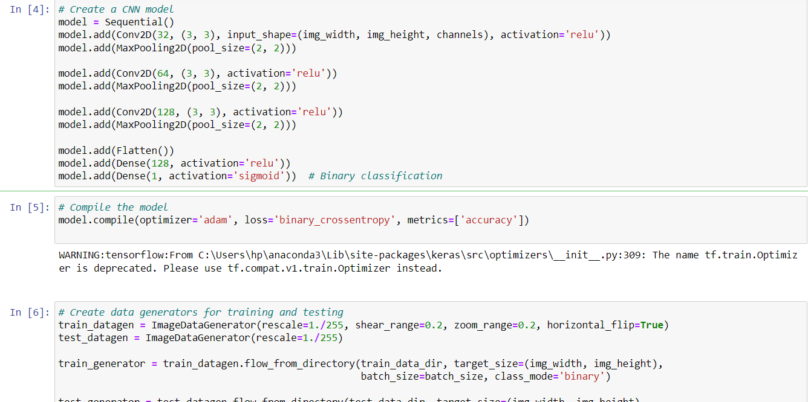

**Pre-trained model:**

Use the Oxford group's pre-trained weights to initialize a VGG model. Use this model directly for picture categorization or use it as a foundation for your own bespoke architecture. Using VGG16, the code initializes a basis model for transfer learning. The 'imagenet' weights are loaded with an input shape of (224, 224, 3), omitting the top classification layer ('include_top=False'). When labeled data is scarce, this VGG16 base model may be utilized as a feature extractor for later layers, making it easier to train new tasks on a convolutional neural network that has already been trained [9]. This frequently improves performance.

IV. Result Evaluation

1. **Impact of overfitting/underfitting and respective solution (at least one solution)**

Overfitting, a phenomenon in data science, occurs when a statistical model precisely conforms to its training data. Unfortunately, in such cases, the algorithm struggles to perform effectively on new, unseen data, undermining its intended purpose. The training data being supplemented to make it more abundant through the process of augmentation. Removing features that are superfluous or redundant and keeping just the most relevant ones [10]. Using early stopping to reduce the number of epochs in deep learning models during training. By reducing overfitting, data augmentation is used to improve the performance of machine learning models [11]. When a model learns from the training data too much, it becomes overfitted and loses its capacity to generalize to new data. Through the provision of a more varied collection of data for the model to learn from, data augmentation helps to mitigate overfitting.

**b. Include the performance evaluation method and compare it with the**

**pre-trained model based on classification evaluation metrics.**

**Performance evaluation of CNN:**

A ROC curve, which stands for Receiver Operating Characteristic curve, is a visual aid that shows how well a classification model performs at different categorization levels. Two important metrics are plotted on this curve: the True Positive Rate and the False Positive Rate. This states that model gave. By presenting several metrics for every class, the classification report offers a thorough assessment of a classification model's performance. Two classes are examined in this study (designated as 0 and 1). The accuracy for class 0 is perfect (1.00), meaning that the model consistently predicts class 0 correctly. Nonetheless, the recall is rather low (0.40), indicating that many real class 0 cases may be missed by the model. The accuracy for class 1 is lower (0.44), suggesting that occurrences of class 1 are infrequently misclassified by the model. However, the recall is quite good (1.00), suggesting that the model accurately captures all of the real class 1 cases. .. The macro and weighted averages offer further information about the model's overall performance across all classes, and the model's overall accuracy is 0.59.

**Confusion matrix:**

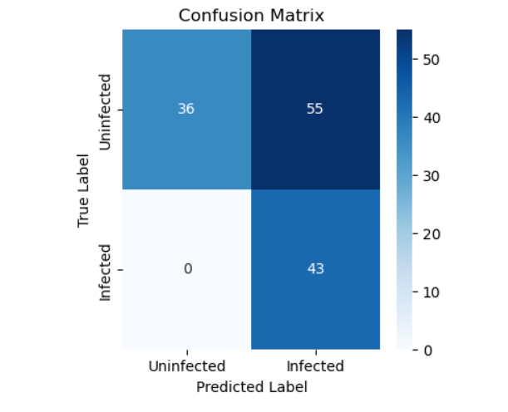**\**

**Pretrained model:**

The model negative precision of (0.66) and recall (0.69) for the uninfected class, which has indicated to properly detect cases and prevent false negatives. The model's accuracy (0.28) and recall (0.26) for the malarial class, on the other hand, are lower, suggesting difficulties in correctly predicting positive cases, which increases the amount of false positives and false negatives. As a measure of the percentage of correctly identified cases, the total accuracy is 55%. The macro average, which takes into consideration both classes, is 0.47, highlighting the need for the overall performance of the model to be improved. In light of class imbalances, the weighted average is likewise 0.55, offering a more sophisticated assessment of the model's efficacy in both classes. It is needed to have more positive class value such as images related to uninfected disease. The dataset played a significant role in the accuracy as this data is minimum which gives minimum accuarcy

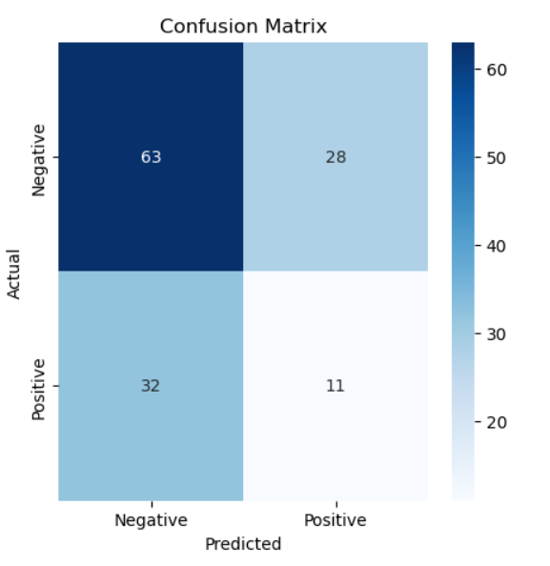

Conclusion

A deep learning network architecture called a convolutional neural network, or ConvNet, is made to extract patterns straight out of data. CNNs are mostly used for image analysis, where they are excellent in recognizing objects, classes, and categories in pictures by identifying pertinent patterns. CNNs work well not just for image recognition but also for audio, time-series, and signal data classification. The network's adaptability arises from its capacity to autonomously assimilate hierarchical characteristics from the input, rendering it a powerful instrument in an array of fields outside visual data processing. In future, I am looking to implement other model to know how accuracy can be increased.

.

References

[1] Schuurmans, D., & Zinkevich, M. A. (2016). Deep learning detection. Advances in neural information processing systems, 29.

[2] Justesen, N., Bontrager, P., Togelius, J., & Risi, S. (2019). Deep learning for disease detection. IEEE Transactions on Games, 12(1), 1-20.

[3] Islam MR, Nahiduzzaman M, Goni MO, Sayeed A, Anower MS, Ahsan M, Haider J. Explainable transformer-based deep learning model for the detection of malaria parasites from blood cell images. Sensors. 2022 Jun 8;22(12):4358.

[4] Shekar G, Revathy S, Goud EK. Malaria detection using deep learning. In2020 4th international conference on trends in electronics and informatics (ICOEI)(48184) 2020 Jun 15 (pp. 746-750). IEEE.

[5] Alok N, Krishan K, Chauhan P. Deep learning‐Based image classifier for malaria cell detection. Machine learning for healthcare applications. 2021 Apr 12:187-97.

[6] Maqsood, A., Farid, M. S., Khan, M. H., & Grzegorzek, M. (2021). Deep malaria parasite detection in thin blood smear microscopic images. Applied Sciences, 11(5), 2284.

[7] Nayak, S., Kumar, S., & Jangid, M. (2019, September). Malaria detection using multiple deep learning approaches. In 2019 2nd International Conference on Intelligent Communication and Computational Techniques (ICCT) (pp. 292-297). IEEE.

[8] Chakradeo, K., Delves, M., & Titarenko, S. (2021). Malaria parasite detection using deep learning methods. International Journal of Computer and Information Engineering, 15(2), 175-182.

[9] Bhuiyan, M., & Islam, M. S. (2023). A new ensemble learning approach to detect malaria from microscopic red blood cell images. Sensors International, 4, 100209.

[10] Alnussairi, M. H. D., & İbrahim, A. A. (2022). Malaria parasite detection using deep learning algorithms based on (CNNs) technique. Computers and Electrical Engineering, 103, 108316.

[11] Molina, A., Rodellar, J., Boldú, L., Acevedo, A., Alférez, S., & Merino, A. (2021). Automatic identification of malaria and other red blood cell inclusions using convolutional neural networks. Computers in Biology and Medicine, 136, 10468